31st Chinna ShodhaYatra
Velugodu to Tammadapally
Dist Kurnool, Andhra Pradesh
14-16 June, 2019

Thirty first Chinna Shodha Yatra (31st CSY)
Date: 14-16 June, 2019
Location: Velugodu to Tammadapally, District Kurnool, Andhra Pradesh
Meeting Point: Velugodu
Starts: Yatra commences at 8 AM on Friday, 14 June, 2019 from Velugodu
Ends: At Tammadapally @ 5 PM on Sunday, 16 June, 2019.
Total Distance: Approximately 54 km.
Route map: https://drive.google.com/open?id=1ocLSeV-iAbrz5a14AF-4tdWL-Ub7ai3_&usp=sharing

To reach the Meeting Point:
Velugodu can be reached by road from Nandyal or Kurnool. Buses are available at high frequency. It is 67 Kms from Kurnool with a travelling time of max 2 hours. From Nandyal, Velugodu is 33 Kms and travel time is an hour.

Return Journey:
On 16 June, 2019, Yatries will be able to reach Kurnool or Nandyal by 7 PM. Return journey may be planned accordingly.

Route we walk…..
14 June – Velugodu, Boyarevula, Aiyyavaripalli, Madhavaram, Thimmanapalle, Narayana Puram
15 June – Narayana Puram, Santa Juturu, G Lingavaram, Ramapuram, Sringavaram, Ernapadu
16 June – Ernapadu, Kadmala Kalwa, Timmapuram, B.Kodur, Thammadapalle

The Yatra area offers:
The region is mostly paddy based farming with sheep and goats in plenty. Water is available for cultivation and for animals adequately throughout the year. Kurnool district is very popular for number of famous temples. Yatries will have an opportunity to visit Mahanandi temple on the last day and see the perennial source of water entering the Temple kolanu which is used by farmers around it for farming as a Blessing of God Mahanandeeshwar. Provides an opportunity to meet hard working villagers. They are cheerful and jovial. Yatra will start from the house of an accomplished Grassroots innovator who lives in Velugodu.

The objectives and other details of the Yatra are described in the brochure placed on the home page of website http://www.pallesrujana.org/. Please read the Brochure carefully for finer details of Yatra. Tips given therein will help you plan the yatra logistics.

You may also read the impressions of yatris who participated in earlier Chinna Shodha Yatras on the website.

Administration
Registration fee of Rs 500 per participant is to be paid at the beginning of the yatra which will be used against the pre-yatra expenses of planning and reconnaissance by Volunteers of Palle Srujana.

Logistics and food expenses during the Yatra will be equally borne by the participants. Estimated expense is Rs 500-700 per Yatri depending on the number of participants. This amount will be collected at the commencement of Yatra by one of the Yatries voluntarily. He/she will maintain the accounts and present the same to the group just before the conclusion of the yatra.

Registration and Cancellation
Please visit www.pallesrujana.org and register online. You can also register by opening the link below. https://forms.gle/gfUJPGVUrnTDCEGa9

Last date of registration Noon 13 June, 2019.

A confirmation of your participation will be sent to you on online registration. In case you wish to cancel the participation after being confirmed, it is incumbent on you to intimate us asap.
Book your to and fro journey and share your travel details with Palle Srujana team and other yatries.

An exclusive whatsapp group for 31st CSY will be opened from 10 June, 2019 and all participants who received confirmation will be included in this group.

Photos of Previous Yatra:
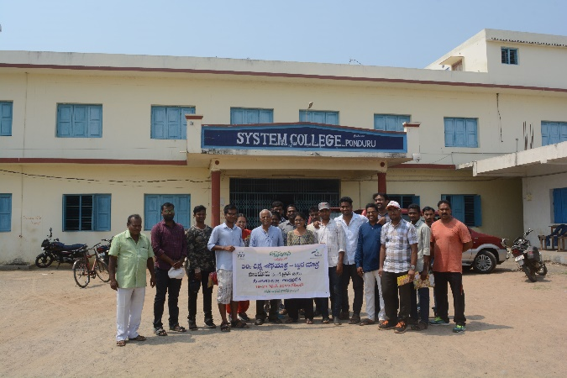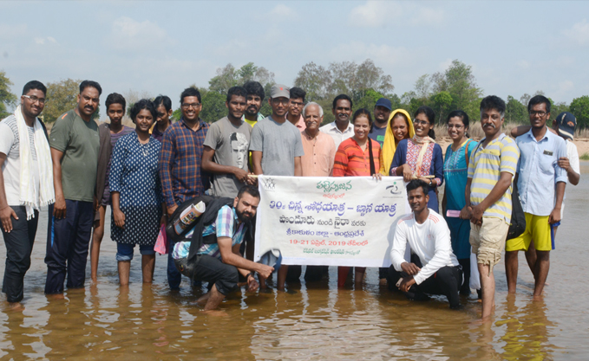
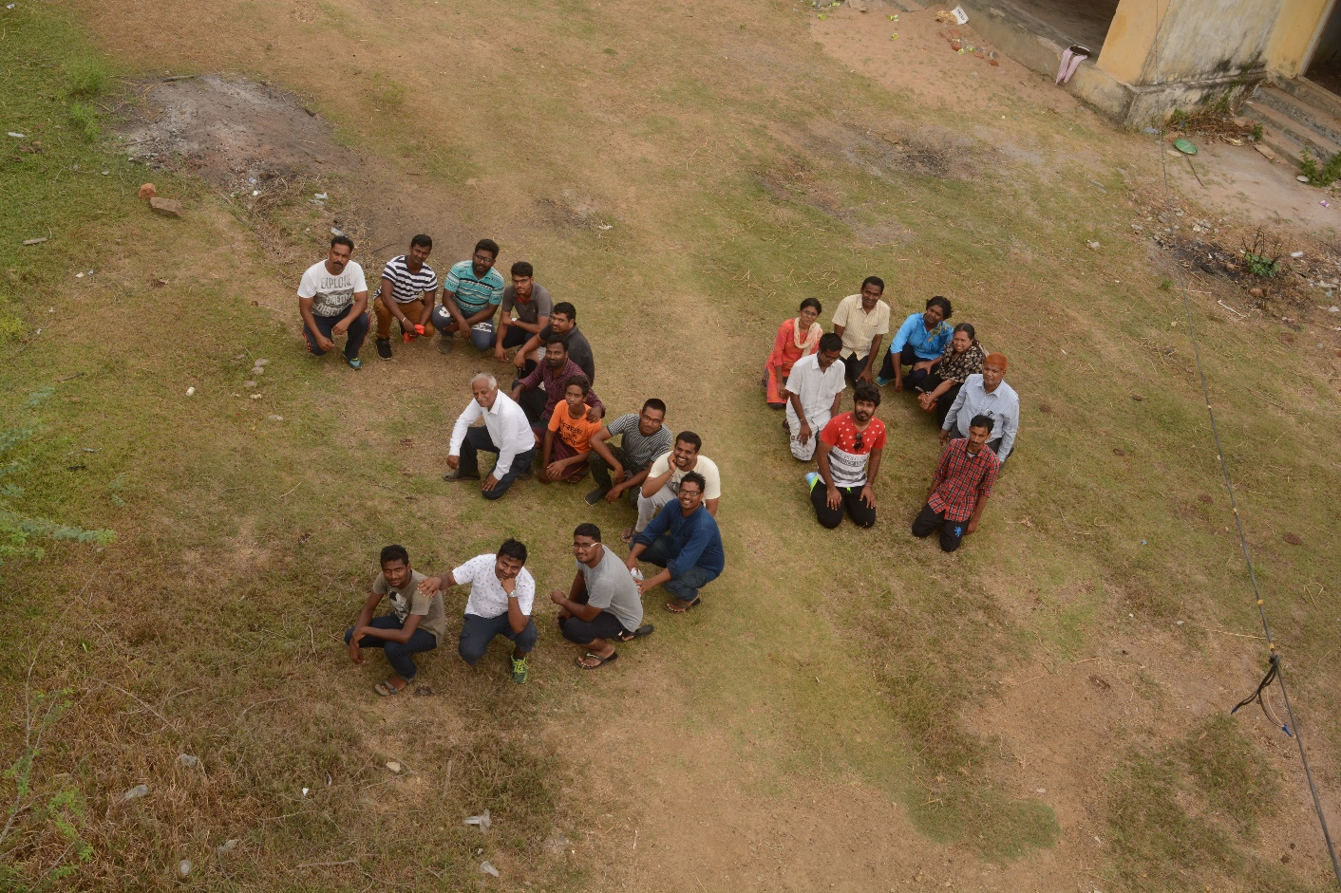

For any queries, please contact or email to:
Raju M, 95028 55858, raju.nif@gmail.com
G Sudarshan, 9966587005, 7989426089, govulas@gmail.com
Brig P Ganesham, 9866001678, president@pallesrujana.org

Please disseminate this flier among your network.

Team Palle Srujana
Secunderabad
May, 2019

